

* The entire testing lifecycle seamlessly converting business processes into automated test scenarios, creating the automation scripts from test steps in natural language, and analysing the execution results for root causes and gaps in coverage, ensuring application and system validation.
* **Introducing 3 core features of kAIros Platform:**

1. **Create: -** The test case generator, our innovative platform seamlessly converts the objective of the application, specified in either structured or unstructured format,

into comprehensive test scenarios, test cases, and detailed test steps utilizing specialised and reusable prompt repositories interacting with various large language models. We prioritize and optimize the test case suite by removing similar and redundant coverage and prioritising the test suites by critical business flows and fragile application modules, maximising testing efficiency and effectiveness.

1. **Execute: -** Execute the Platform, expedites the generation automation scripts in popular open-source frameworks in industry tools, eliminating the need for complex coding techniques in laborious maintenance.
2. **Analyse: -** With predictive real time analytics, gaining valuable insights with a heatmap view identifying potential root causes or enterprise applications. The platform leverages process intelligence tools to mind the customer usage in data variants to derive the business processes, achieving a higher level of quality assurance, ultimately enhancing overall system reliability and business continuity. Our platform kAIros dynamically learns from production usage, automatically generating high quality test cases and real time test data for comprehensive end to end coverage.



* Enterprises can confidently navigate the complexities of modern software development, ensuring flawless customer experiences while accelerating their time to market.



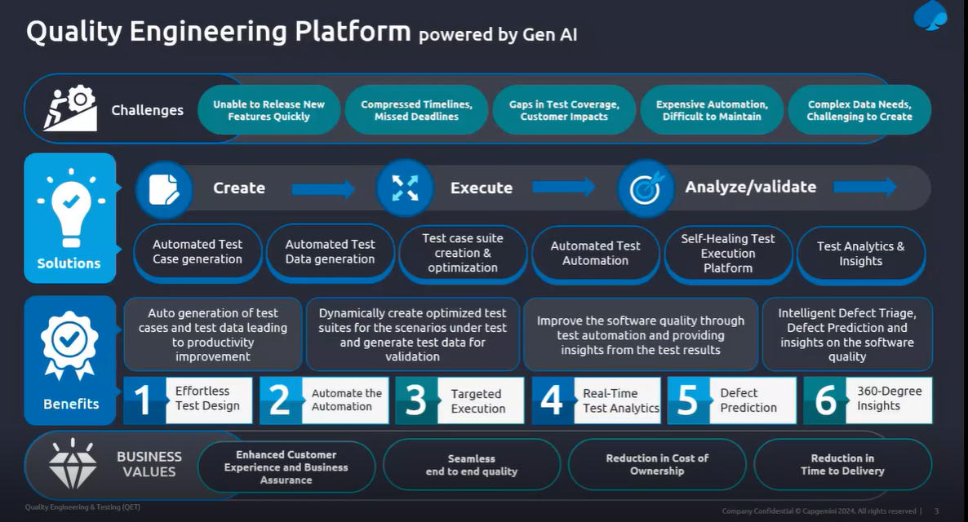

* As we discussed above the Gen AI platform comprises of 3 major components. One is the create, the next one is execute and 3rd one is the analyse or validate. So, as you have seen above, the create part is the core component of this. We call that as a test case generator.

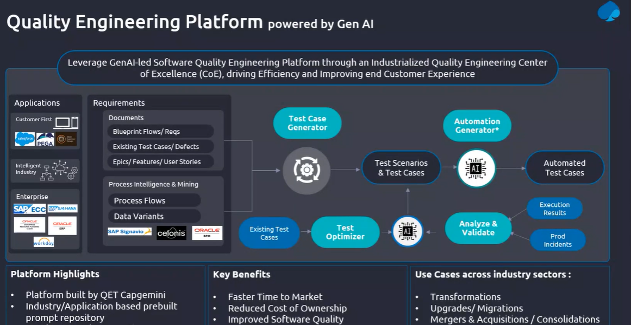

* It can support any type of application. It is the technology agnostic they don’t have any restriction that it will support only this type of technology or doesn’t support any technology. So, all you need to understand it will work for any of the technology whether it is in graphical format or pictorial format it does works and gives us the desired output here. It will accept any type of application. The requirements from the any type of application can be processed using this platform.
* It can consume any of the requirement document and process it and extract the details or the scenarios or function feature test cases out of their documents. That is possible. And, in case you don’t have high level document, but you have only the users’ journeys or user experience like your epic document available or a set of users to you want to automate that is also possible. You can pick up each epic by a pick. You will be able to load it and give the acceptance category or the exit detail.
* What all the available information is there from there we will be able to auto generate all possible test scenarios out of it. That is also possible. or some cases if you have a detailed process flow bug for example on the business team given the workflow format like you know any BPNBPNM file format or flow chart diagram format right, Business process model notation format, any format, if you have any process flow diagram still this platform can consume that image. We have an image binding automation is available.
* where it can take the images of your process flows as an input. It will synthesis extract all the available information or components workflows in that document in that file and from that it will be able to generate the functional test cases. All possible combination of test scenarios out of the business process flow that is also possible. So, it supports any type of requirements structured or unstructured requirement available as part of your project plan that can be consumed and processed and generated the test scenarios out of it.
* The advantage here is like, the productivity is far better than the manually you create, Whatever the manual test created manually those can be created by Gen AI platform efficiently. Using this platform, you will be able to multi fold, you will be able to fast track it, it will be generated faster. And, as you fine tune it or the prompts you give a proper prompt and accurate prompts, you will be able to generate accurate test cases related to a specific to our application or no specific to the context what you are setting it.

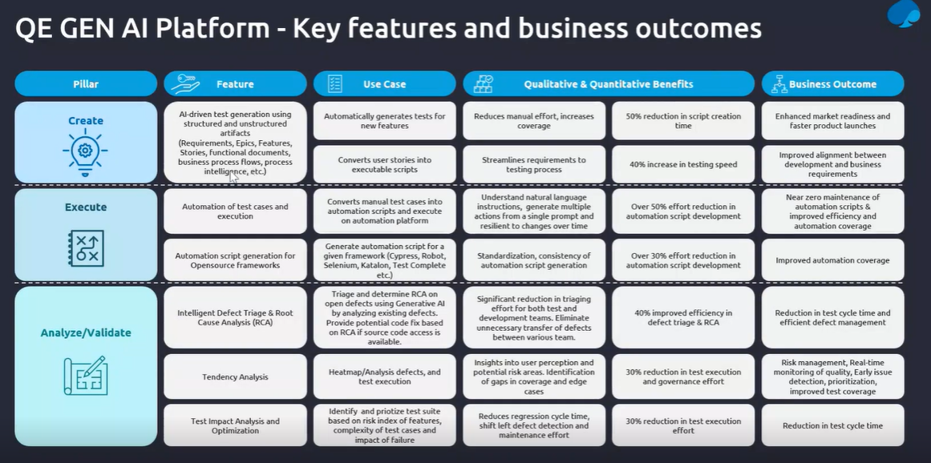

KAIros Platform URL - <https://kairos--test.azurewebsites.net/>

You can go through “Help” we have detail info related to every module here.

Document analysis:

Steps:

1. Need to create a solution by filling all the required fields 🡪near solution type (we need to select required application e.g. Web, sales force, etc and if the application related to java or .Net u can select custom option from drop down) near data model (we need to select client using test management tool e.g. Jira, azurdevops etc)
2. And then we need to go to documents tab once after creating solution in this already the required documents will be uploaded if we want any other doc’s should upload we can upload them, those should be in csv or txt format this format only LLM’s (large language model) will understand if we have doc file or any other file we need to convert that into csv or txt format.
3. Select document which is needed and click on analyze.
4. And then select the already configured prompt from the drop down and select the existing document and click on AI Analyze document.
5. Now Gen AI Platform consume this BRD document which we have selected, and it will be sent to LLM (large language model) and then LLM will do the further analysis and gives the desired o/p based on our request in the form of test scenario’s format.

I don’t have access for the below modules: -

1. After that will go for SAP document analysis tab (If we need to create any solution related to SAP, we need to go to this module) and need to fill the desired fields
2. And click on “AI generate SAP process flow test case” option by using above prerequisites that what all we selected above. Then it will throw the possible scenarios as o/p.
3. And same we need to do for SAP Business requirements analysis module to generate the scenarios.
4. All the above modules are used to create the scenarios based on our requirement.

**How to create functional test cases through image/ Flow chart/ Graph Any form of pictorial representation: Image Processing**

* He shown this feature process in Dev environment we don’t have an access yet for this Platform this feature is not in production environment, it’s in our MVP (Minimum viable product) version and it’s still under development. So, I have added the screenshots for better understanding.

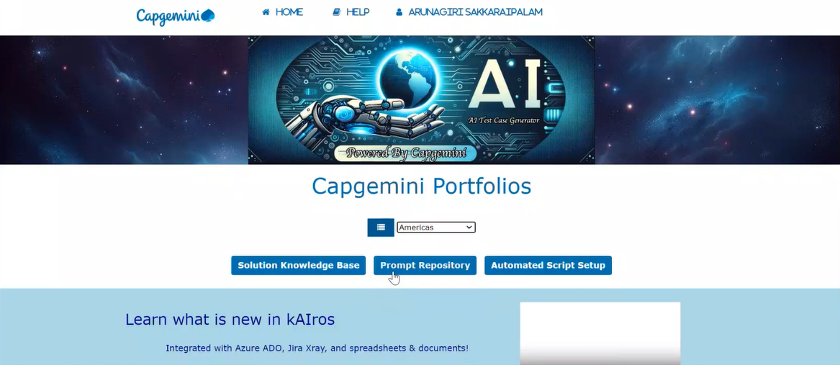

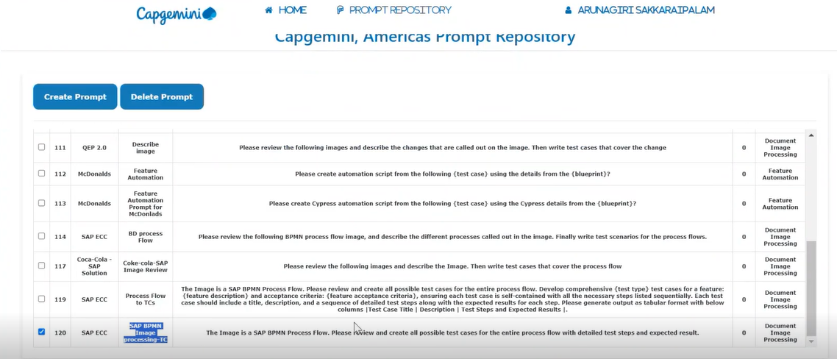

1. In homepage, you can select the portfolio as your requirement for example as Americas, then click on prompt repository. So, what are the prompts required across all the modules, those all defined over there in the repository. So, there we can create the new prompt by clicking on create prompt we can give any name based on project related terms. And we can delete the created prompt in the prompt repository by selecting that prompt and click on delete prompt.

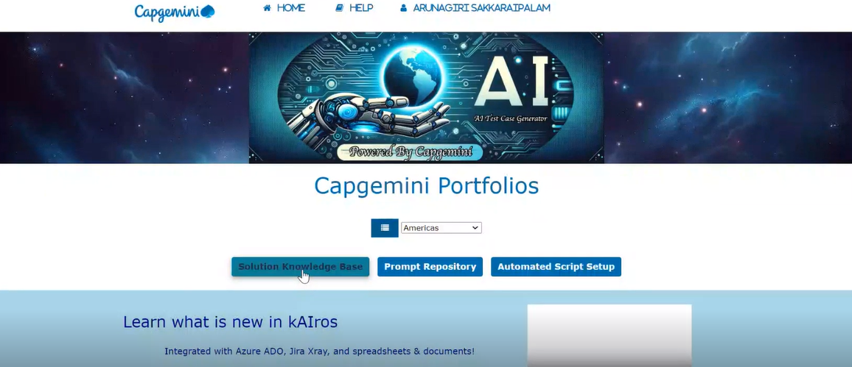

1. Now we need to go back to home page and select the portfolio and select solution knowledge base and select the required solution and click on analyze.

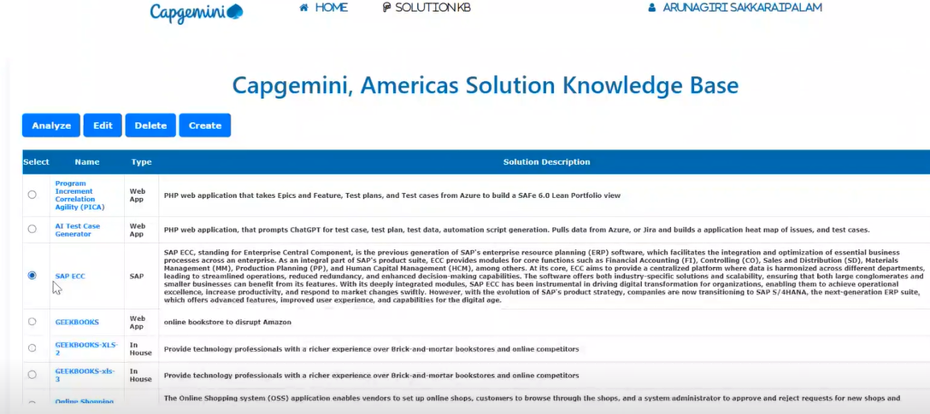

1. Go to Documents

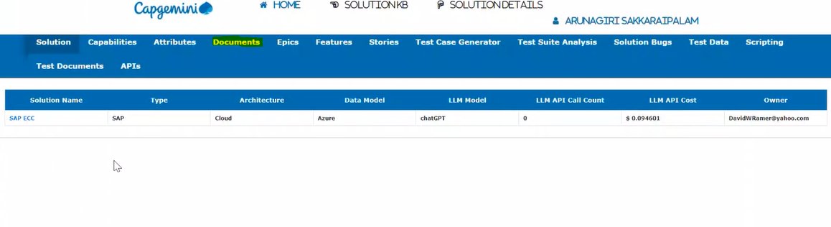

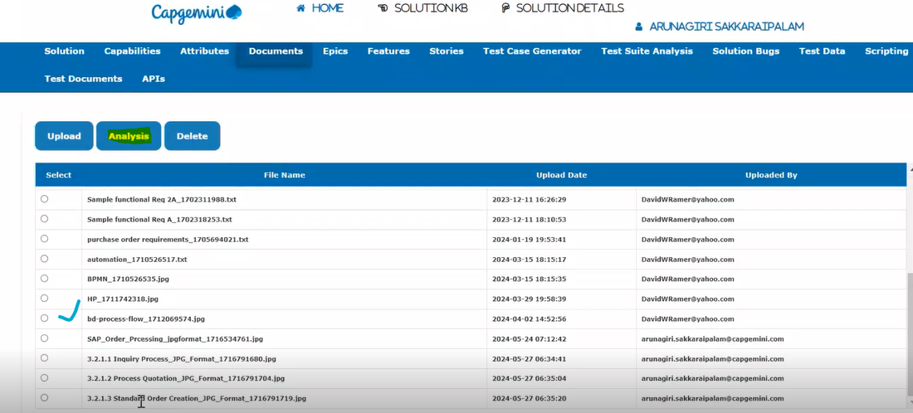

1. select the image which one you want to process. and then Click on Analysis and select Image processing.

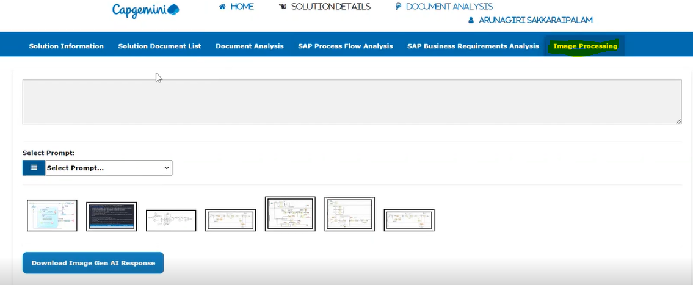

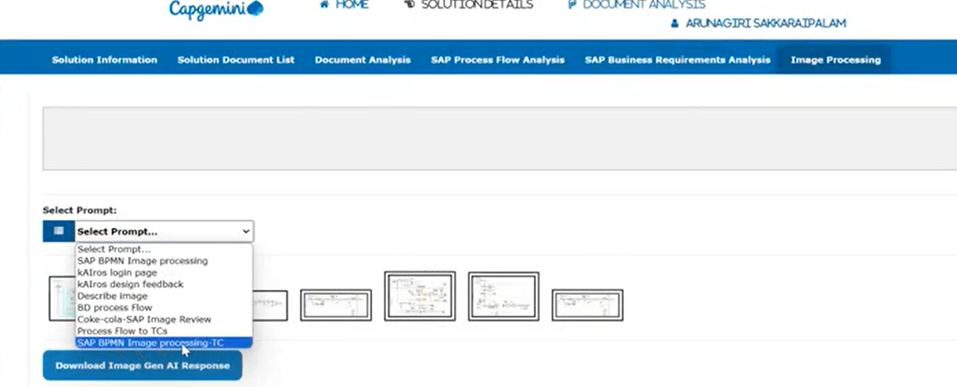

1. select the prompt and the desired image which one you want to convert into a test case. Once after selecting image.it will synthesise all the information from the image and it will try to extract all the possible test scenarios out of it. So, what all the prompts we configured we take that as an input, here we are takings image as an input. And Gen AI platform throws all the possible test scenarios as an output. And once after o/p gets generated we can download the Gen AI response in the form of text document.

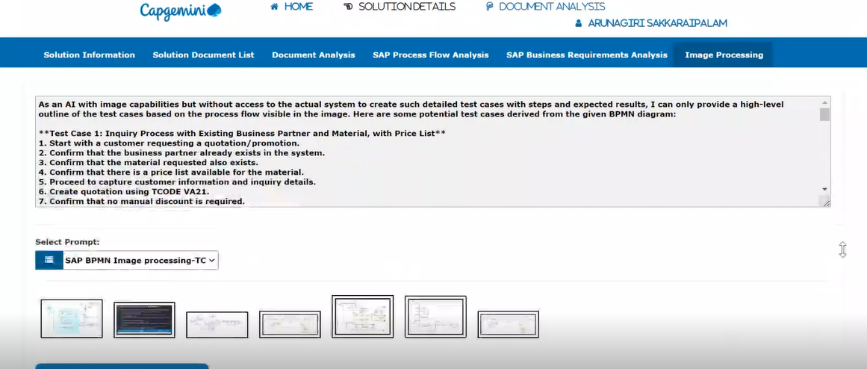

* **Quality Engineering**

**IDTA - Intelligent Defect Triage (RCA- Root Cause Analysis) Automation**

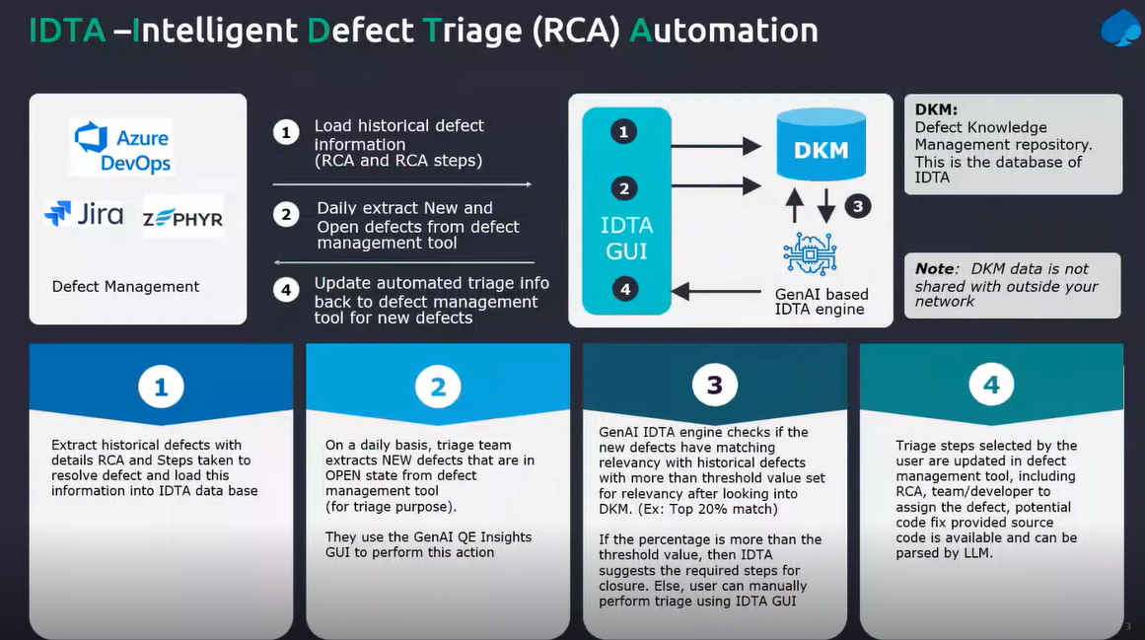

**IDTA** - Intelligent defect Triage automation

1. Initially as soon as if we want to raise any defect then we will be analysing all the open defect one by one. And the first and foremost thing we need to understand is before the moment you would log a defect, the team needs to understand is there any similar defect Logged before, If the similar defect logged before, we would see that who worked on that defect.
2. It is from which team who is the tester raised this defect whether if it is exact duplicate then we can go back and reopen the defect instead of creating a new defect.
3. So, this defect intelligent automation will help us to understand the existing defect and it will suggest us what is the potential root cause for that defect and is there any similar defect exist in the system. If it exists, what is the nature of the defect and what are the details about the defect. the complete root Cause analysis whatever you perform in the defect analysis meeting. this tool will be going to help us by giving all the details about the defect.

**Test Environment**

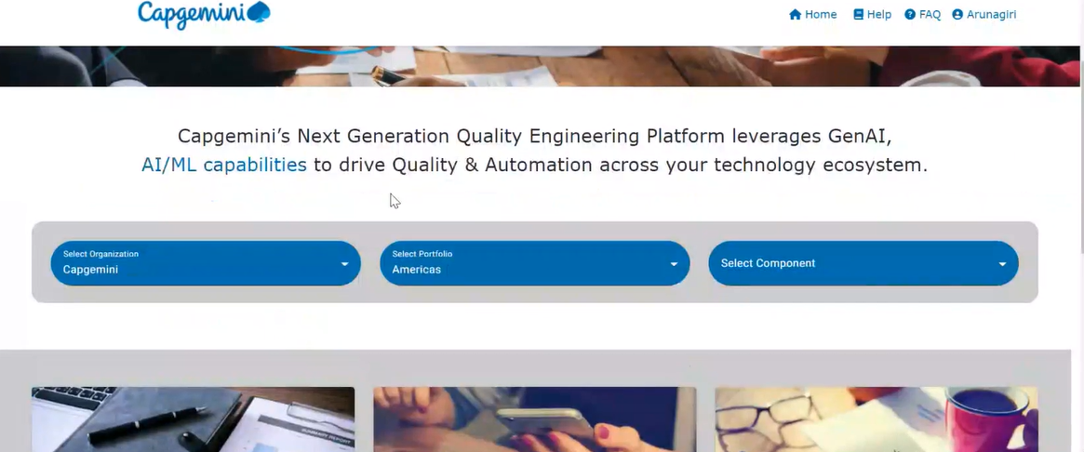

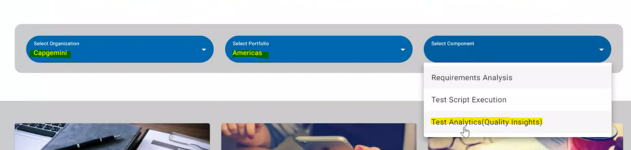

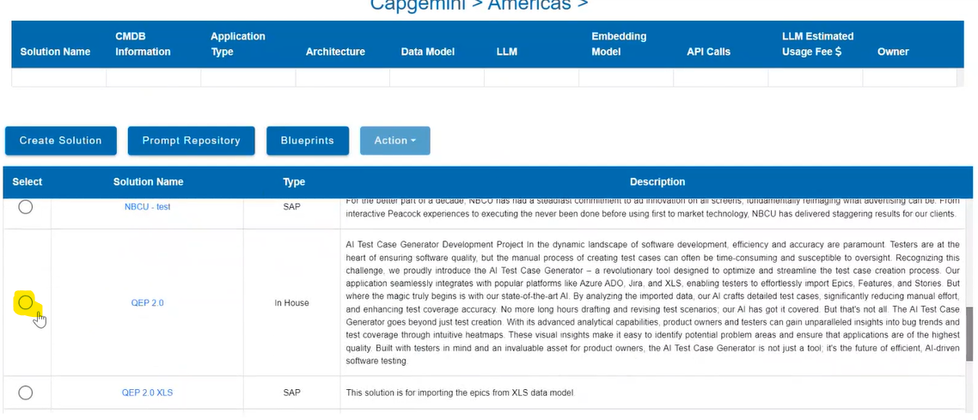

Select application to perform root cause analysis, scroll up or go back to menu and select “Defect Knowledge Management”.

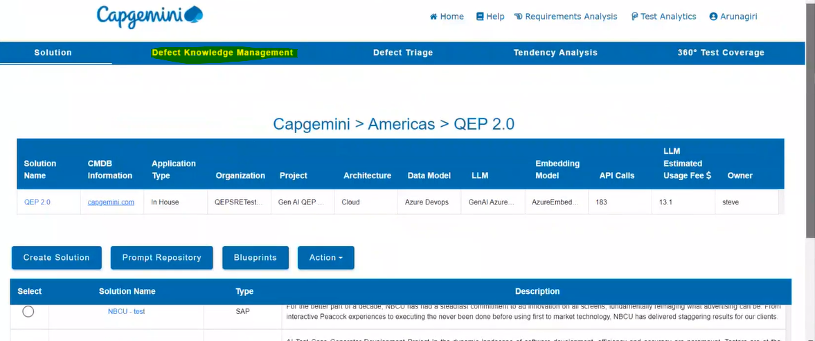

* To import any of the defect to this Gen AI platform It should link with Zira or Alm etc applications to import any of the defect if not we can’t import the defect.

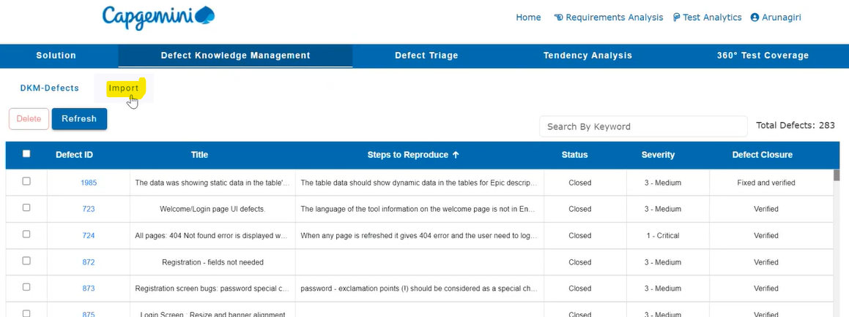

* first thing we need to do is import the defect. then what the system will do is like, it will import all the defects exist in the repository, including the closed all the status defects and it will import all the defects and build a defect knowledge management repository (DKM).
* Now after importing the defects from repository from ALM or Jira or any defect management system then come to this screen called Defect Triage and then come to Defect signatures tab and we need to select all the defects and create the defect signature and update the defect acknowledgement management.

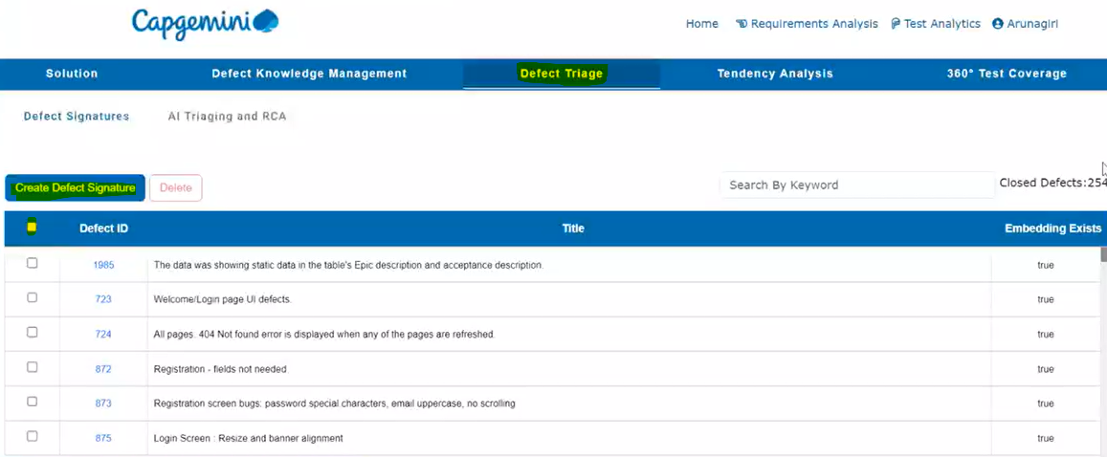

* The above step is the prerequisite step for this activity. Once this is done, then go to the AI Triaging and RCA (Root cause analysis).

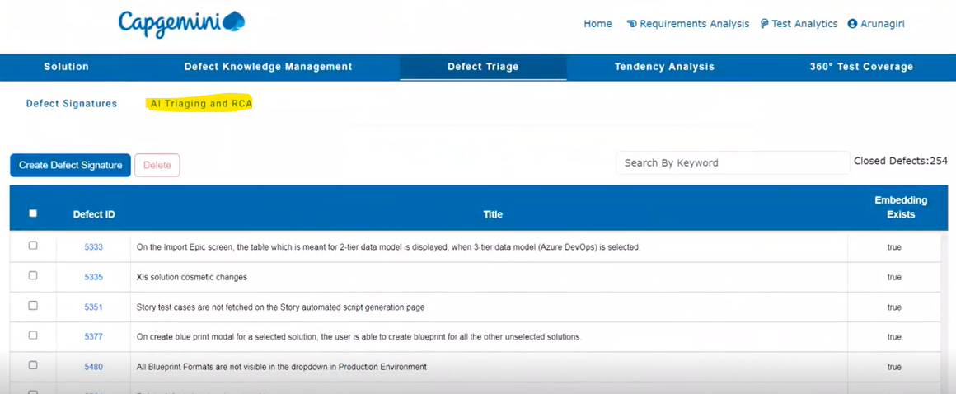

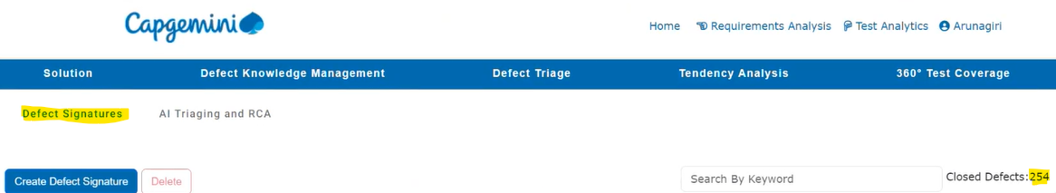

* Here in the defect signature, if you look at it, there are 254 defects that include all the defects like the closed status, open status all the defects. So out of which in the defect Triage typically will perform the triaging for the open defects. So out of the 254 defects, there are 27 defects is available for AI Triaging it is nothing, but the open defects will be shown in AI Triaging there are 27 available.

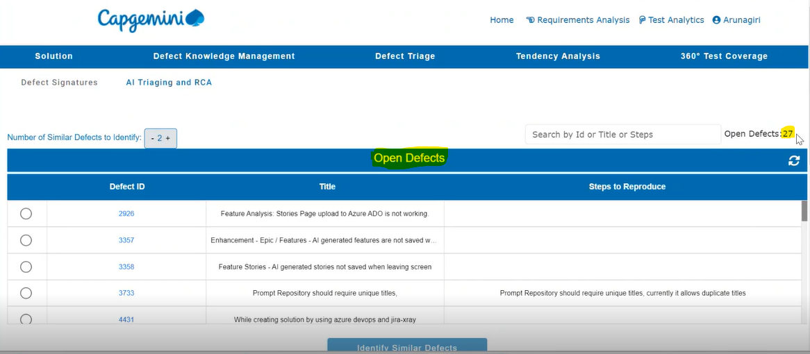

* Here you can set the threshold value. It is nothing but If I want to understand or identify the top 20% or the top 2 defects, which matching my current defect, so for that we can adjust the value by increasing or decreasing, then, that many open defects will be shown which matches the current defect, then we will get to know that what all the similar defects are exist in the system so that we can go through that existing defect and understand what is already there in the current defect details whether those are already covered or is there any portion is not covered so that we need to raise a new defect That will help us to understand. Through this AI Triaging.

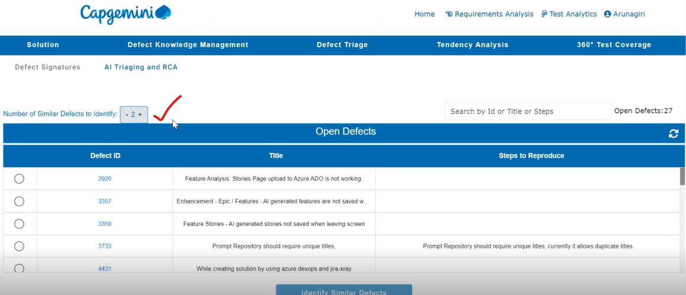

* You can search defect through ID or title or any step that you know in search bar

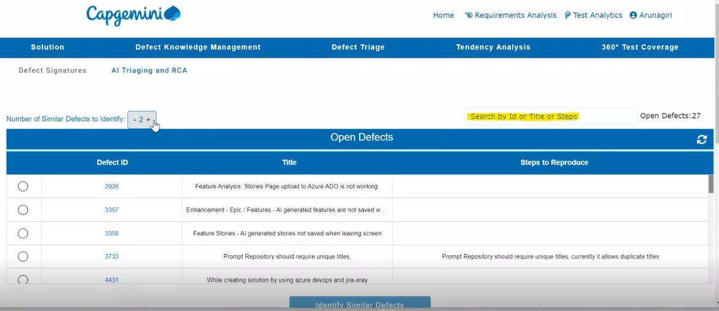

* Search with the desired defect and click on Identify Similar defects if we didn’t find any similar defect we can raise a new defect.

